Received by:

Date:

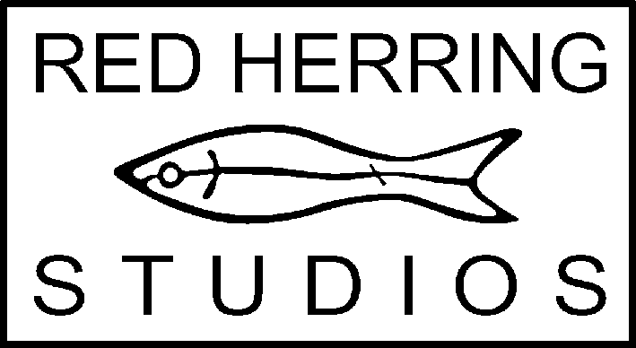
Red Herring Studios
Unit 5
Wellington House
Camden Street
Portslade
BN41 1DU

Red Herring
Red Herring exists as an artists’ cooperative to provide a studio base and space of shared interests for artists/makers to produce work and thereby make a contribution to the cultural life of the local, regional and wider community.

Red Herring is managed, maintained and funded by its members. Whilst studio spaces are individual, sharing this responsibility is an implicit part of membership and members are required to contribute to the running of the studios and attend meetings as the primary process of organisation and decision-making.

Applicants are offered spaces, when available, according to members’ feedback on application, appropriateness to space available, seriousness of approach and in keeping with a policy that maintains a range of practices and avoids discrimination on grounds of gender, sexual orientation, age, ethnicity or belief.

The offer of a studio space is conditional on the following:
1 Payment of one month’s rent in advance
2 Arrangement of a standing order for rent payment (on 3rd of each month)
3 Payment of a returnable deposit (2 x monthly rent)
4 Submission of a Risk Assessment covering all materials, processes and equipment involved in the applicant’s practice
5 Designation of a studio job or role

Membership
Initially studio use is probationary, for a period covering at least 2 consecutive Red Herring General Meetings (these are normally scheduled every other month). In this period new members are asked to demonstrate their willingness to attend meetings and take an active part in the running of the studios. After a satisfactory probationary period, and by mutual agreement, full Membership is confirmed at a subsequent General Meeting.

APPLICATION FOR MEMBERSHIP

Name
Address
Tel.: landline |  | mobile
Email |  | website
Social media
Date of Birth |  | Gender

Name

Describe your work (media, scale, themes, etc.) … continue on another sheet if needed

Do you have specific studio requirements? (e.g. blackout, power, concrete floor, water, etc.)

Where are you currently making work?

Have you been a member of a shared studio before? (please give details)

Indicate your likely pattern of studio use

Indicate your understanding of the benefits and obligations of a cooperative group and why are you interested in this kind of studio space
Name

Indicate how you will be able to contribute to the maintenance of the studios and the running of Red Herring as an organisation

Indicate how your work contributes to the cultural life of the area (and beyond) …. e.g. through exhibition or public work, educational or community activity, artist initiative, etc.

Add any further details or information in support of your application

Please return this form, along with your CV, printed images of your work and any other supporting material to the Spaces Co-ordinator c/o the studios (address above).

We endeavour to safeguard materials sent but Red Herring and its members cannot be held responsible for any accidental loss or damage and applications are not normally returned. Do not send originals.

Following application we normally only contact applicants if/when a space may be available or if we are unable to accept the application.

Please keep us informed of any changes in you circumstances.

Signature below indicates permission for your details to be held on our application file.

Signature |  | Date

